**PF Online Transfer Process**

[www.epfindia.gov.in](http://www.epfindia.gov.in)

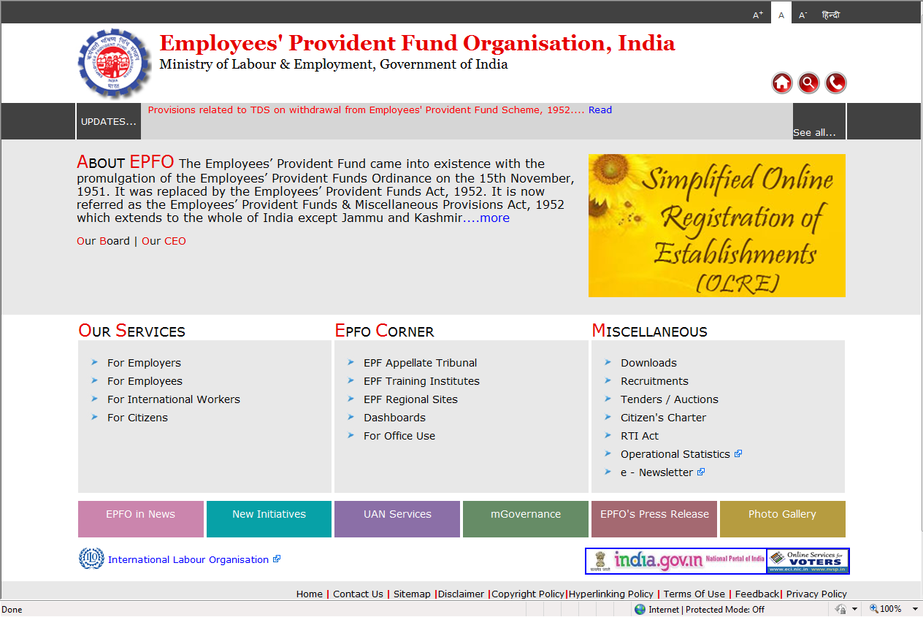

**Click on >For Employees**

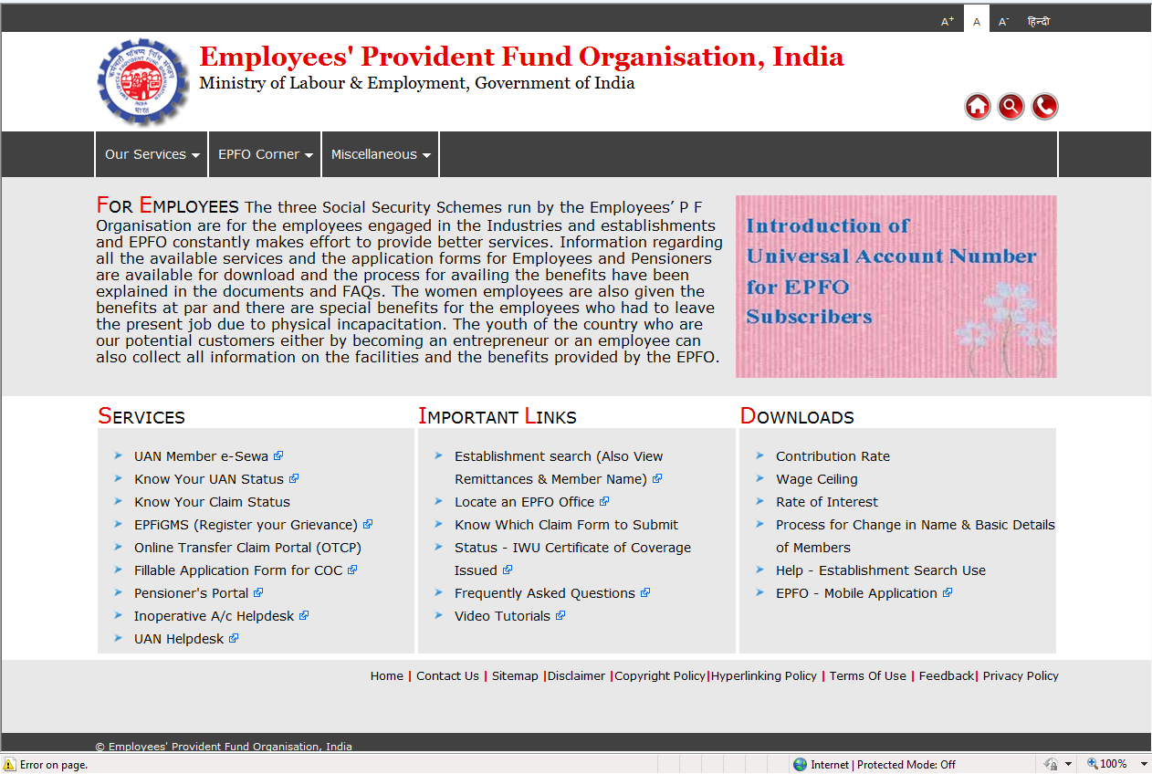

**Click on > Online Transfer Claim Portal (OTCP)**

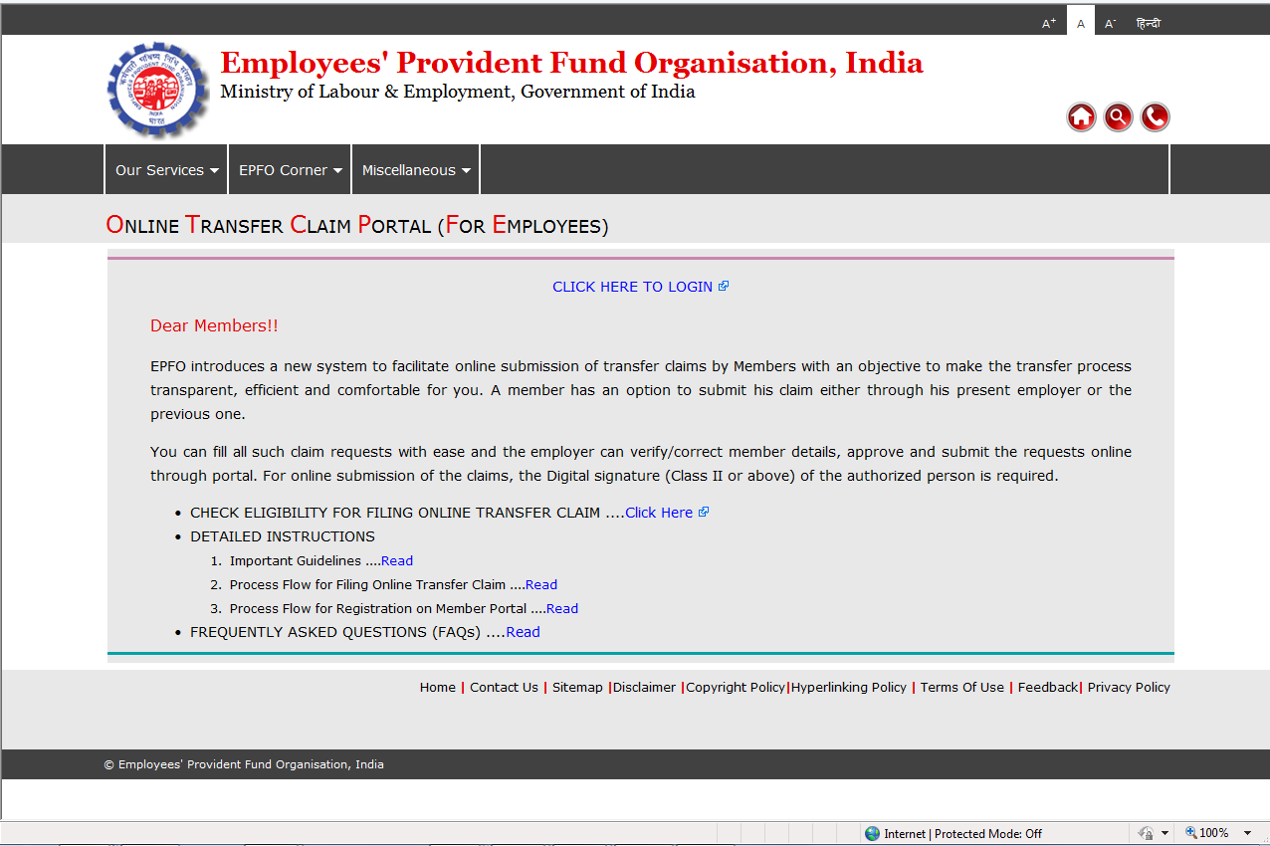

**Click on “CLICK HERE TO LOGIN”**

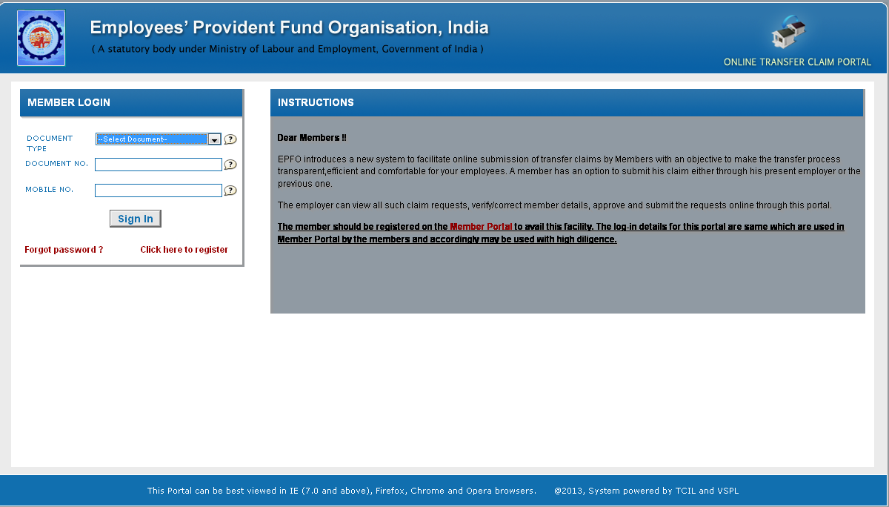

**If you have already registered then Select the document type, Document Number and Mobile Number and click on Sign In.**

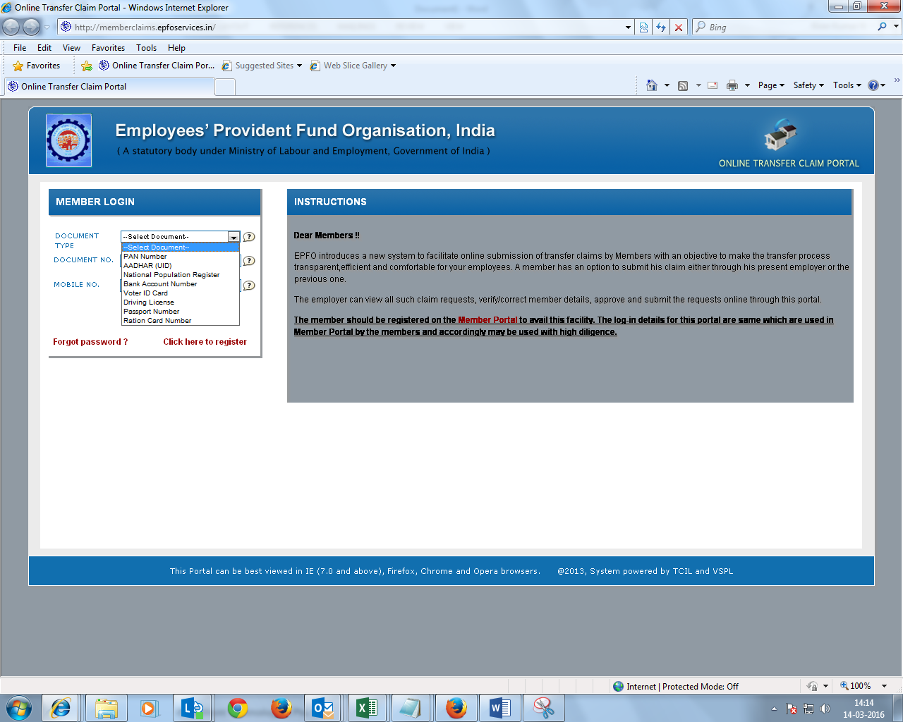

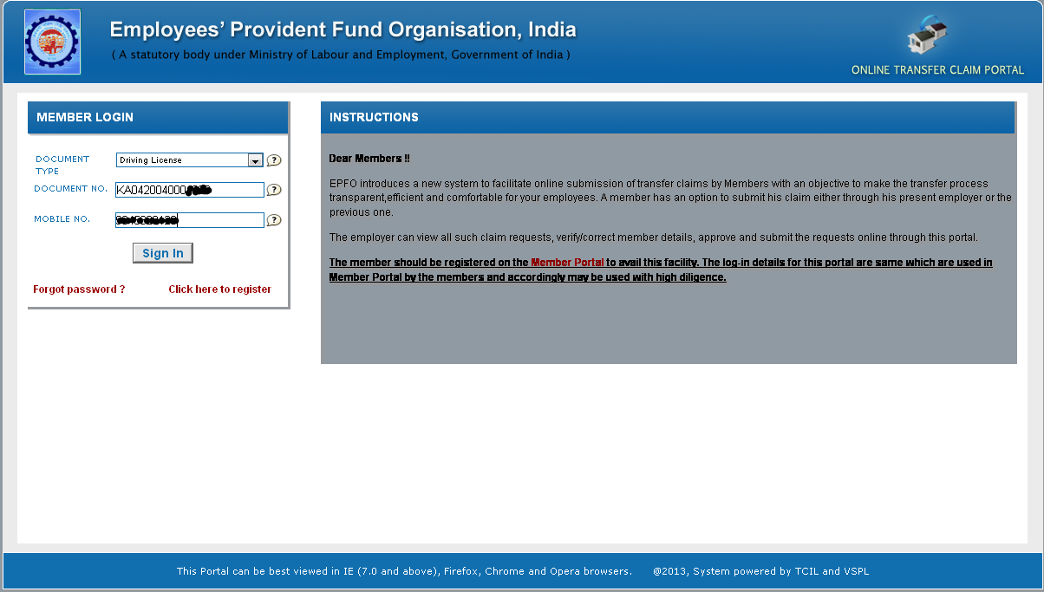

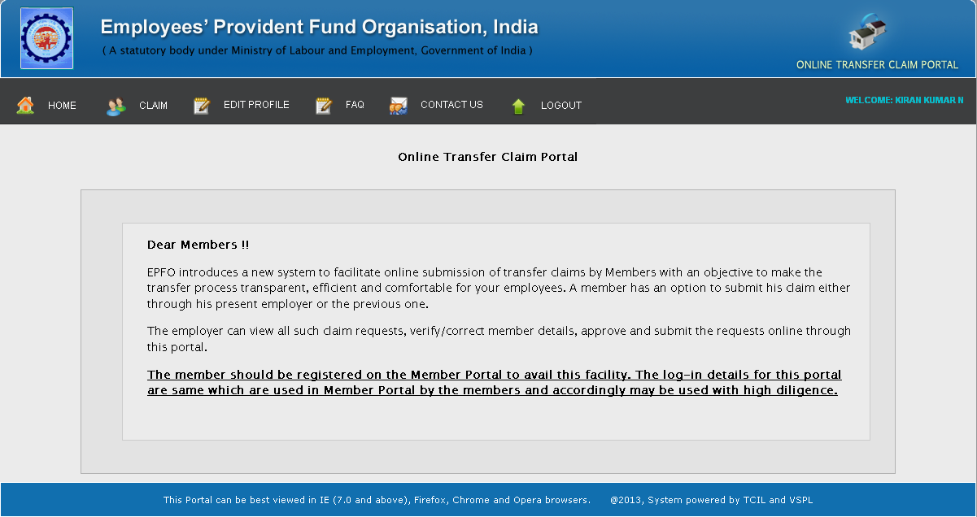

**Go to Claim – Check Claim Eligibility**

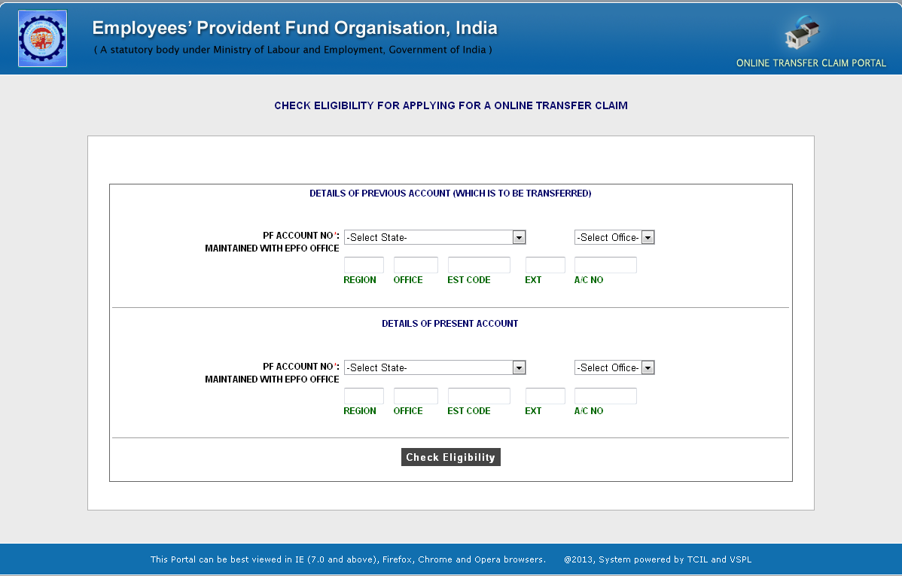

**Select State from the dropdown where your Previous Employer PF is administered, Select PF Office where your Previous Employer PF is administered, automatically Region and Office code will populate, type Establishment Code, in Extension type 000 and in Account number key in your PF Account Number ( For example, if your PF Account Number is PY/KRP/19214/12345, then Establishment code will be 19214, extension will be 000 and Account Number will be 12345). After keying in both details, click on check Eligibility, if both employer has registered Digital Signature in the EPFO portal you will be prompted to proceed as shown in the below screen.**

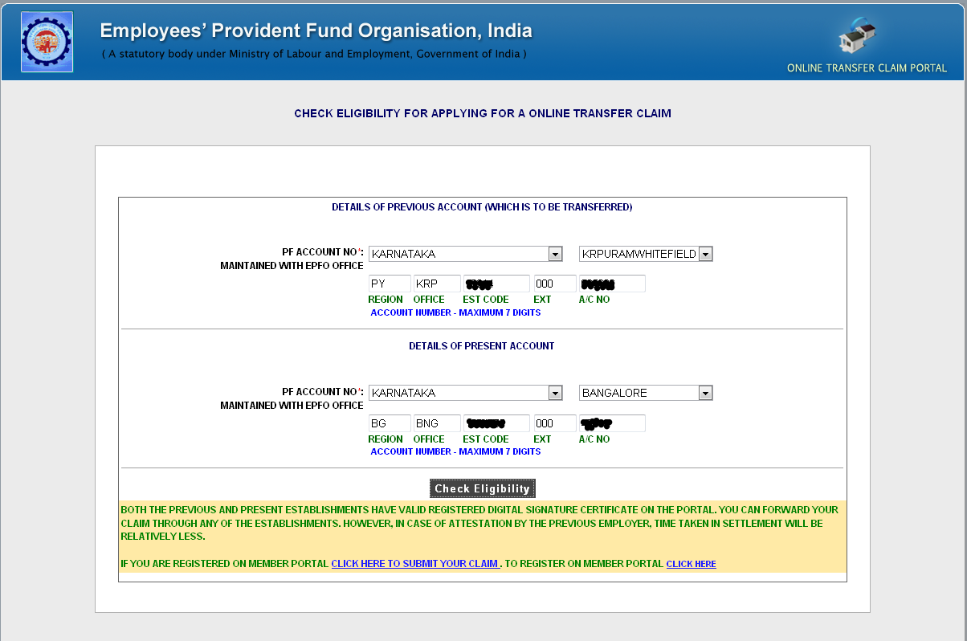

**Close this browser and go to your Home Page, Under Claim click on “REQUEST FOR TRANSFER OF ACCOUNT”**

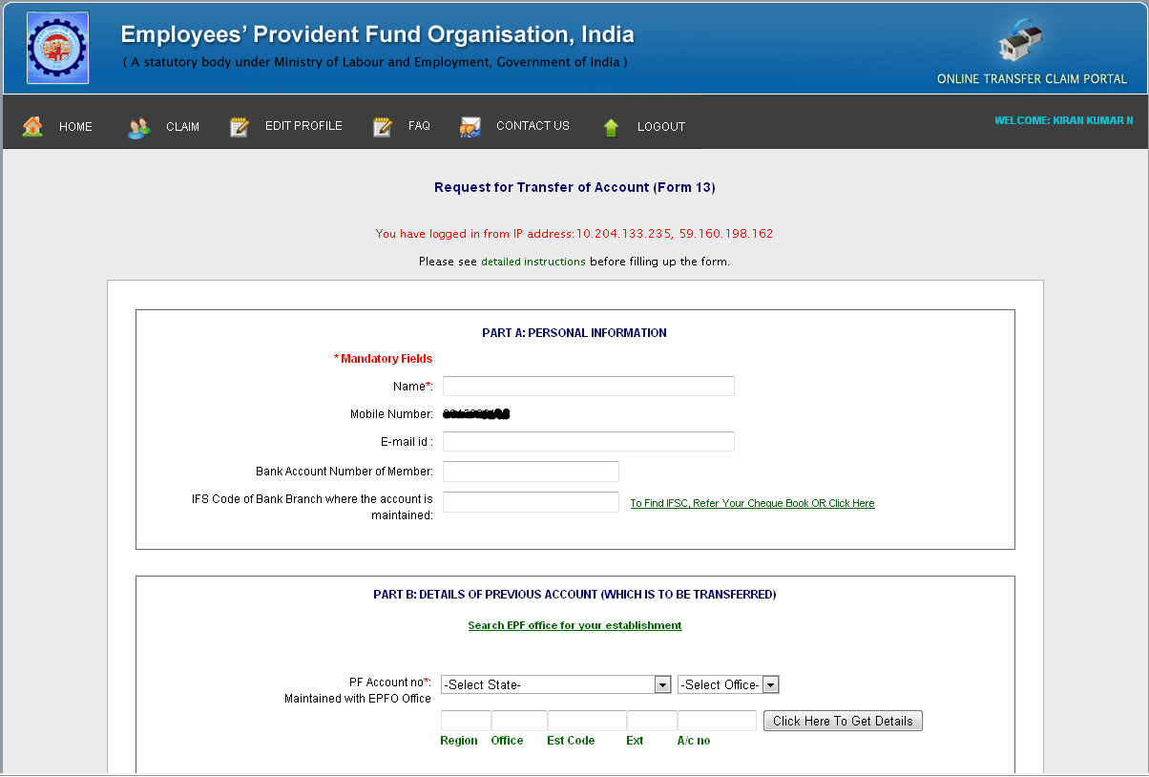

**Key in your Name, Email id in Part A , In Part B, Select State from the dropdown where your Previous Employer PF is administered, Select PF Office where your Previous Employer PF is administered, automatically Region and Office code will populate, type Establishment Code, in Extension type 000 and in Account number key in your PF Account Number ( For example, if your PF Account Number is PY/KRP/19214/12345, then Establishment code will be 19214, extension will be 000 and Account Number will be 12345), click on “Click Here To Get Details” button, the details will be auto populated**

**Note - If any of the information is blank, they key in correct details with the specified format**

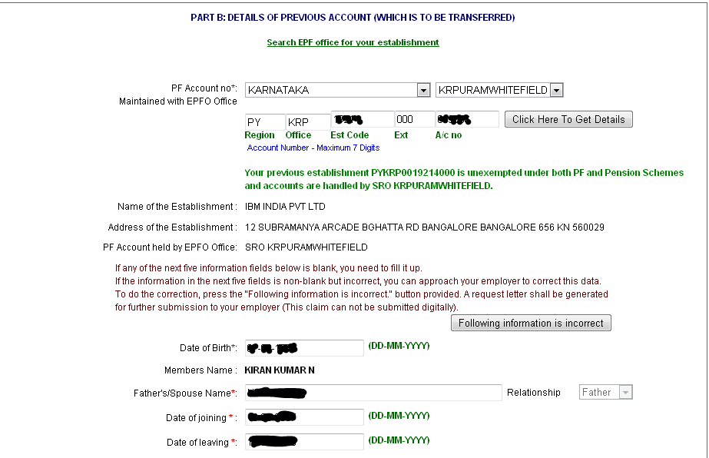

**In Part C, Select State from the dropdown where your Present Employer PF is administered, Select PF Office where your Present Employer PF is administered, automatically Region and Office code will populate, type Establishment Code, in Extension type 000 and in Account number key in your PF Account Number ( For example, if your PF Account Number is PY/KRP/12345/67890, then Establishment code will be 19214, extension will be 000 and Account Number will be 12345), click on “Click Here To Get Details” button, the details will be auto populated.**

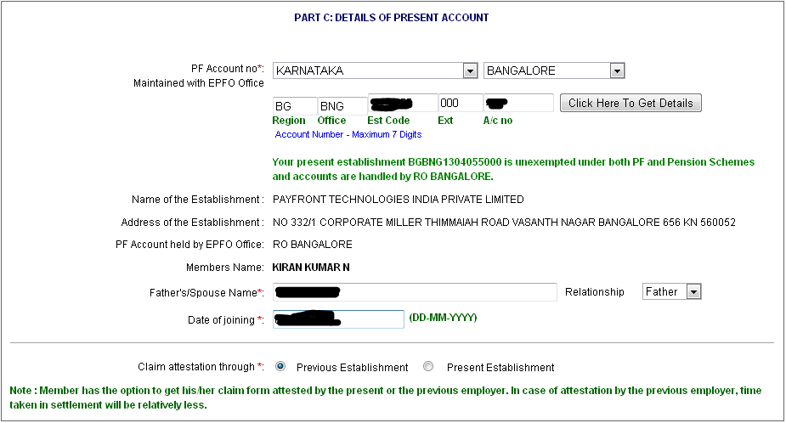

**By default the radio button will be checked on Previous Establishment. If you initiate your PF Transfer through Previous Establishment, the time taken will be relatively less than selecting Present Employer.**

**Click on Preview Button**

**Verify the information which will appear in Next screen, once all the details are correct, Type the Characters which will be displayed on the screen and click on Get Pin button, OTP pin will be sent to your registered mobile number, check box I agree box and type the OTP which you would have received on your Mobile Number and click on Submit Button. A PDF will be generated, take a printout of the same, sign and send it to your Previous Employer for approval.**

**If you have not registered to perform the above activity, follow the below steps**

[**www.epfindia.gov.in**](http://www.epfindia.gov.in)



**Click on >For Employees**



**Click on > Online Transfer Claim Portal (OTCP)**



**Click on “CLICK HERE TO LOGIN”**

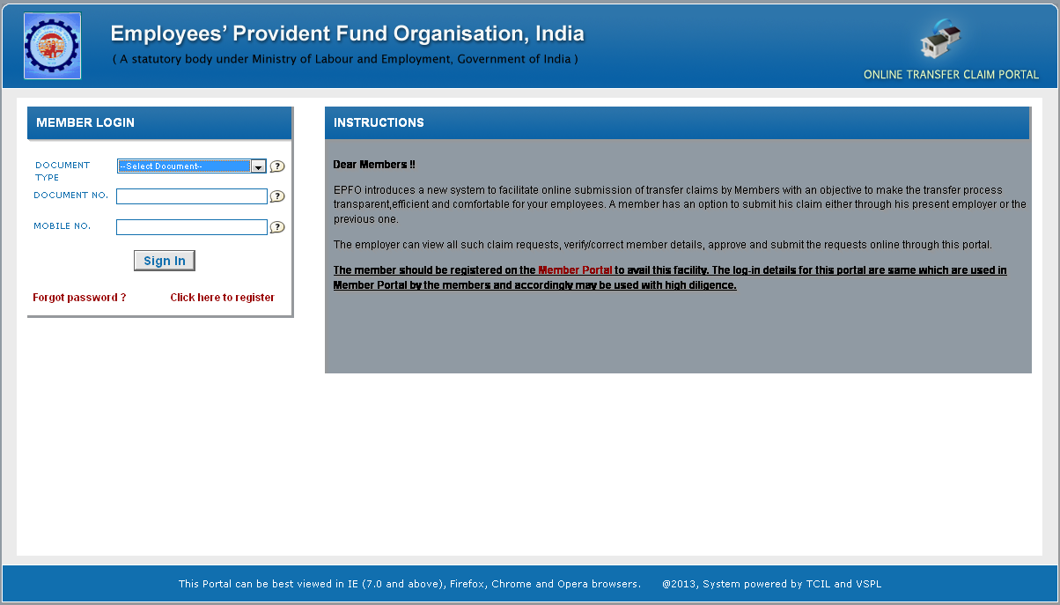

**Click on Click here to register**

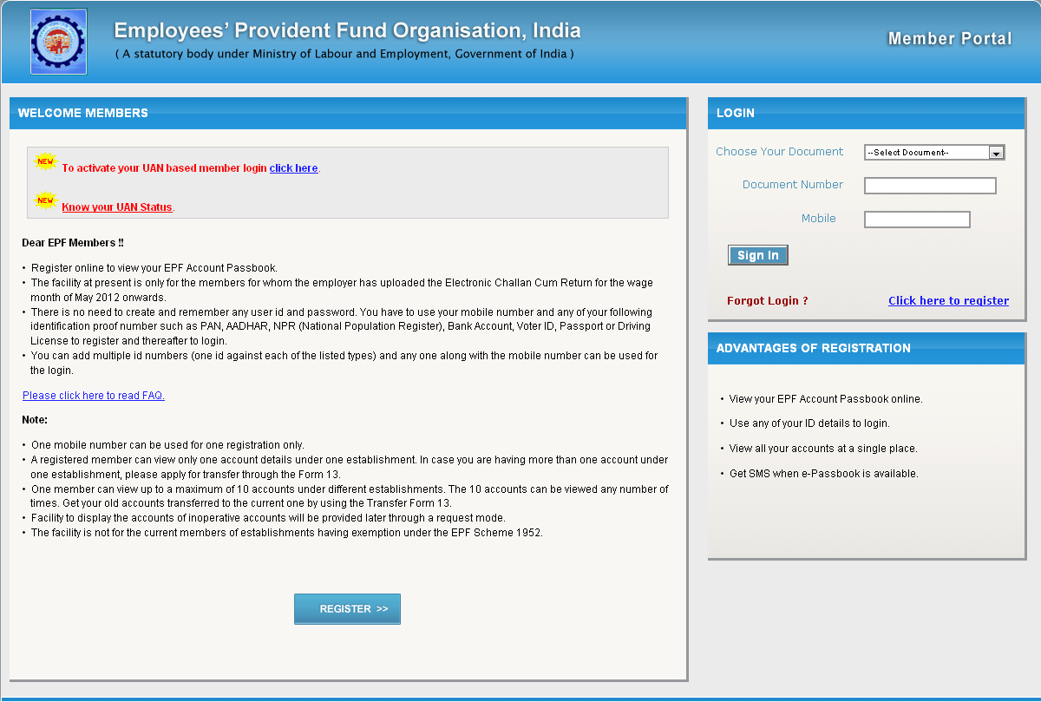

**Click on REGISTER>> button**

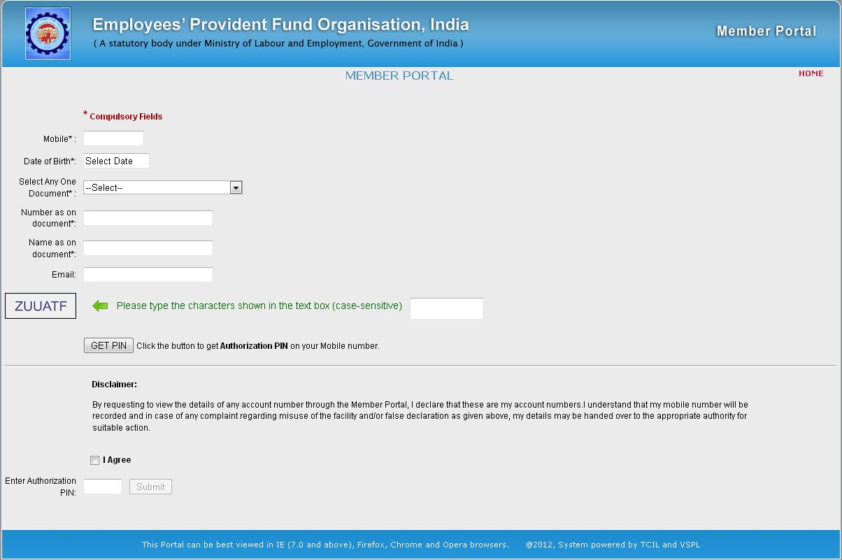

**Type your Mobile Number**

**Select your Date of Birth**

**Select any One Document from the drop down**

**Enter the Document Number (For example, if you have selected PAN Number as Document, type your PAN Number as document Number)**

**Enter Name as on Document (For example, if you have selected PAN Number as Document, type your Name as per your PAN Card)**

**Enter your Personal Email ID**

**Type the Characters displayed on the screen and click on GET PIN button.**

**An authorisation code will be received on your Mobile, check box I Agree and Enter the authorisation code which you would have received on your Mobile and click on Submit button.**